Hasan alhwietat

[Company name]  [Company address]

[Document title]

Contents

Agendas & Action Items 1

Team Canvas 10

Early Thoughts 11

Mind Maps 13

Challenge Discovery 14

Final Challenge Statement 16

Research Questions 16

Customer 19

Idea Brainstorming 22

Prototyping Plan 25

Solution Description 26

User Testing 27

Features & Benefits 29

Value Proposition Canvas 29

Market Size 31

Competitive Landscape 33

Marketing Mix 35

Brand Voice 36

Go To Market 38

Initial Operating Expenses 38

Cost Structure 39

Revenue Model 40

Pricing 41

Breakeven Analysis 42

Projections 43

# Agendas & Action Items

Instructions:

Team captains will fill the information below for each team storm meeting.

This is mandatory and will affect your performance, also it is an opportunity for you to get in the habit of documenting and keeping your team on the same page, while informing us of your ongoing progress.

Note that absence from an agreed upon team meeting is an absence that will be recorded.

----------------------------------

Storm Meeting # 0

Date: 26/10/2022

Participants: Izzat Al-Najjar, Saif Elayan, Mahmoud Rummaneh, Hasan Al-hwietat

Absent: -- None

Duration: 1:18 hour

**Key Areas/Issues Discussed or Worked On:**

* Team Forming and storming
* Choose a team leader
* A discussion about the video we want to make, the role of each person in the video, and what kind of music we want to use
* Choose a name for the team
* We chose Sunday to shoot the video and its date 30/11/2022

**Action Items & Responsibility:**

* We discussed ideas for making the video (All team)
* As for the team leader, we took a quick vote to choose him
* As for the name of the team, we suggested several names and voted

Team Captain Signature:



 ----------------------------------

Storm Meeting # 1

Date: 31/10/2022

Participants: Izzat Al-Najjar, Saif Elayan, Mahmoud Rummaneh, Hasan Al-hwietat

Absent:-- None

Duration: 2:15 hours

**Key Areas/Issues Discussed or Worked On:**

* We made a team logo design
* We made a montage of the video
* We started working on the operating manual, especially the team canvas.

**Action Items & Responsibility:**

* Logo design (Saif & Hasan)
* Montage video(Izzat & Mahmoud)
* Team canvas(All Team)

Team Captain Signature:



 ---------------------------------

Storm Meeting # 2

Date: 8/11/2022

Participants: Izzat Al-Najjar, Saif Elayan, Mahmoud Rummaneh, Hasan Al-hwietat

Absent:-- None

Duration: 2:05 hours

**Key Areas/Issues Worked On:**

* Early Thoughts (Challenges we face in our daily lives)
* Mind Map (organizing our ideas)

**Action Items & Responsibility**

* Early Thoughts (Hasan & Izzat)
* Mind Map (All Team)

Team Captain Signature:

 Storm Meeting # 3

Date: 14/11/2022

Participants: Izzat Al-Najjar, Saif Elayan, Mahmoud Rummaneh, Hasan Al-hwietat

Absent:-- None

Duration: 3:23 hours

**Key Areas/Issues Discussed or Worked On**

* We have suggested many problems that we face in our lives and identified the appropriate one
* We put many questions related to the problem
* We have suggested some places we want to go that will help us find the answers
* We have determined the time that we will go to the places we have targeted
* Suggested design research questions

**Action Items & Responsibility**

* Research on the problem we agreed on as per the following:
* Research among university students (Izzat & Mahmoud)
* Research among Car owners within the targeted segment (Saif & Hasan)
* ………..

Team Captain Signature: ….



 ----------------------------------

Storm Meeting # 4

Date: 23/11/2022

Participants: Izzat Al-Najjar, Saif Elayan, Mahmoud Rummaneh, Hasan Al-hwietat

Absent:-- None

Duration: 3 hours

**Key Areas/Issues Discussed or Worked On**

* Research the topic of the Customer Persona more accurately
* We analyzed the data we collected
* We worked on the customer persona of our project

**Action Items & Responsibility**

* Research customer persona (Saif & Izzat)
* Analyzed data (Mahmoud & Hasan)
* User persona number one (Saif & Mahmoud)
* User persona number two (Hasan & Izzat)

Team Captain Signature: ….



 ----------------------------------

Storm Meeting # before stage gate

Date: 27/11/2022

Participants: Izzat Al-Najjar, Saif Elayan, Mahmoud Rummaneh, Hasan Al-hwietat

Absent:-- None

Duration: 2:45 hours

**Key Areas/Issues Discussed or Worked On**

* We collected the data and arranged it inside the presentation that was completed in the previous stages
* Putting the finishing touches on the playbook
* Presentation training

**Action Items & Responsibility**

* Presentation (All Team)
* Playbook (Hasan & Izzat)
* Training (Saif & Mahmoud)
* ...

Team Captain Signature: ….



 ----------------------------------

Storm Meeting # 6

Date: 3/12/2022

Participants: Izzat Al-Najjar, Saif Elayan, Mahmoud Rummaneh, Hasan Al-hwietat

Absent:-- None

Duration: 2:00 hours

**Key Areas/Issues Discussed or Worked On**

* We discussed the subject of the prototype plan
* Putting the finishing touches on the playbook
* We are looking for VPC

**Action Items & Responsibility**

* Finished the VPC (All team)
* Take a step in the prototype plan (All team)
* ...

Team Captain Signature: ….



 ----------------------------------

Storm Meeting # 7

Date: 10/12/2022

Participants: Izzat Al-Najjar, Saif Elayan, Mahmoud Rummaneh, Hasan Al-hwietat

Absent:-- None

Duration: 5:00 hours

**Key Areas/Issues Discussed or Worked On**

* Prototype plan
* How we will make the prototype
* The validation of our features in the app

**Action Items & Responsibility**

* Giving ideas to build the app(All team)
* Working on the app(Mahmoud & Hasan )
* Working on the playbook(Saif & Izzat)
* Prototyping plan (All team)

Team Captain Signature: ….



 ----------------------------------

Storm Meeting # 8

Date: 15/12/2022

Participants: Izzat Al-Najjar, Saif Elayan, Mahmoud Rummaneh, Hasan Al-hwietat

Absent:-- None

Duration: 12:00 hours

**Key Areas/Issues Discussed or Worked On**

* Prototype plan
* Marketing plan
* Business model

**Action Items & Responsibility**

* Complete the first prototype(Mahmoud & Saif)
* Working on the playbook (Hasan & Izzat)
* ...

Team Captain Signature: ….



------------------------------------------------

Storm Meeting # 9

Date: 28/12/2022

Participants: Izzat Al-Najjar, Saif Elayan, Mahmoud Rummaneh, Hasan Al-hwietat

Absent:-- None

Duration: 4:00 hours

**Key Areas/Issues Discussed or Worked On**

* Second Prototype
* Customer journey
* ...

**Action Items & Responsibility**

* Working on the second prototype(Izzat& Saif)
* Complete the customer journey (Hasan & Mahmoud )
* ...

Team Captain Signature: ….



 ----------------------------------

Storm Meeting # 10

Date: 4/1/2022

Participants: Izzat Al-Najjar, Saif Elayan, Mahmoud Rummaneh, Hasan Al-hwietat

Absent:-- None

Duration: 5:00 hours

**Key Areas/Issues Discussed or Worked On**

* Prototype
* Customer journey
* ...

**Action Items & Responsibility**

* Update the second prototype(Hasan & Mahmoud )
* Working on financials (Izzat& Saif )
* ...

Team Captain Signature: ….



 ----------------------------------

Storm Meeting # 11

Date: 11/1/2022

Participants: Izzat Al-Najjar, Saif Elayan, Mahmoud Rummaneh, Hasan Al-hwietat

Absent:-- None

Duration: 6:00 hours

**Key Areas/Issues Discussed or Worked On**

* Prototype (MVP)
* GTM
* ...

**Action Items & Responsibility**

* Complete the second prototype(Hasan & Mahmoud )
* Dealing with the feedback data (Izzat& Saif )
* ...

Team Captain Signature: ….



---------------------------------

Storm Meeting # 12

Date: 17/1/2022

Participants: Izzat Al-Najjar, Saif Elayan, Mahmoud Rummaneh, Hasan Al-hwietat

Absent:-- None

Duration: 3:00 hours

**Key Areas/Issues Discussed or Worked On**

* Pitch Design
* Prototype
* Playbook
* ...

**Action Items & Responsibility**

* Final touches on prototype(Hasan ,Mahmoud ,Izzat & Saif )
* Working on the presentation (Hasan ,Mahmoud ,Izzat & Saif )
* Final touches on playbook (Hasan ,Mahmoud ,Izzat & Saif )
* ...

Team Captain Signature: ….



----------------------------------

Storm Meeting # 13

Date: 18/1/2022

 Participants: Izzat Al-Najjar, Saif Elayan, Mahmoud Rummaneh, Hasan Al-hwietat

Absent:-- None

Duration: 5:00 hours

**Key Areas/Issues Discussed or Worked On**

* Playbook
* Presentation
* ...

**Action Items & Responsibility**

* Complete the presentation (Hasan ,Mahmoud ,Izzat & Saif )
* Complete the playbook (Hasan ,Mahmoud ,Izzat & Saif )
* ...

Team Captain Signature: ….



# Team Canvas

**Part 1***(Due one week after Teams are formed)*

*After discussing with your team the Thinking and Behaving Preferences discussed during Team Day. Include for each team member the following:*

1. *MPA & LPA of your thinking preferences. (Most Preferred & Least Preferred Attribute)*
2. *Behavior Preferences (Expressiveness, Assertiveness, Expressiveness)*
3. *Hacker, Hustler, Hipster or Hound*

Team Name: Hunters

Members:

* Izzat Al-Najjar (Hacker) (Assertiveness)
* Saif E’layyan (Hound) (Expressiveness)
* Mahmoud Rummaneh (Hipster) (Assertiveness)
* Hasan Al-hwietat (Hustler) (Expressiveness)

 ————————————————————

Izzat Al-Najjar MPA & LBA: Creative/laziness

Mahmoud Rummaneh MPA & LBA: Positive/ Overthinker

Hasan Al-hwietat MPA & LBA: Sincere/Brutally Honest

Saif E’layan MPA & LBA: Balanced/impatience

**Part 2**

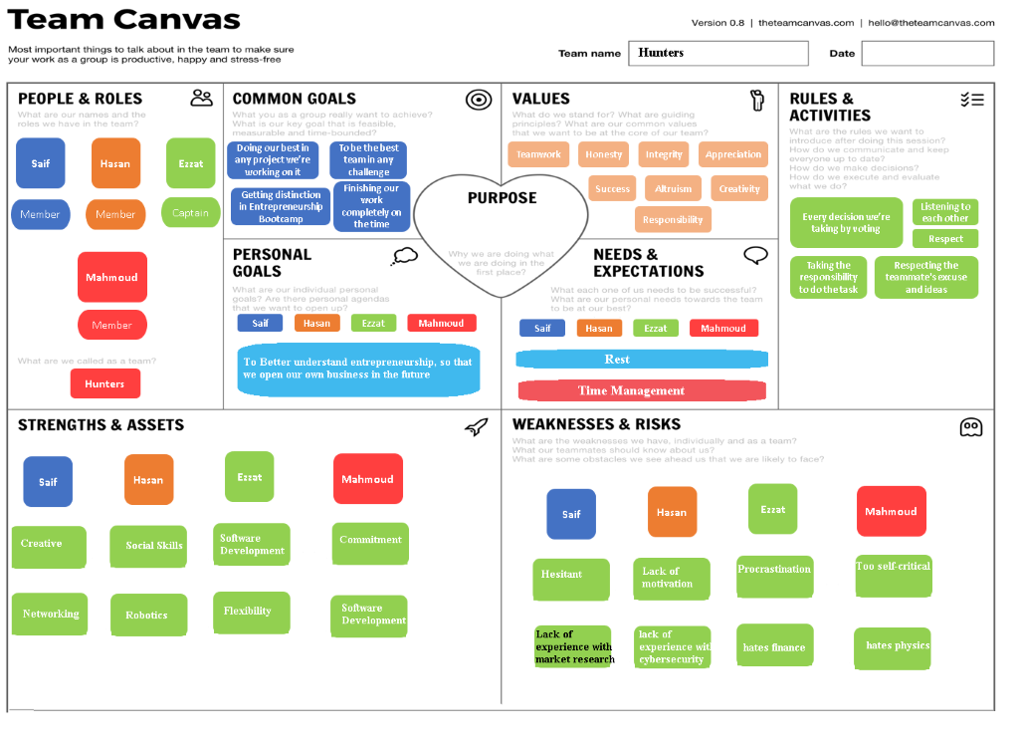*Have a look and get acquainted with the Team Canvas. We will let you know when we expect you to work on it, but for now just keep the questions in the back of your mind.*

# Early Thoughts

*Instructions: In this section, you will be exploring different challenges that your team can dive deeper into. Fill the tables as you see fit (you can fill one or both)*

1. Most successful companies start with the founders trying to solve a problem in their own lives. ***Always write your early thoughts as a question because you still don't know the answer!***

|  |
| --- |
| **What challenges do you face in your everyday life that need a better solution?** |
| Ex. I would like to be more sustainable when I go grocery shopping but everything is packaged in single use plastic – is there a way to make the shopping experience more sustainable? |
| I would like to be more sustainable when I commute to work/school, but public transportation is  extremely bad, which leads me and other people to commute to my/their jobs with their own cars, therefore leading to extensive traffic jam.    There's no backup generator when the electricity cut-offs.    Facing traffic, and congested roads first thing in the morning puts people in a grumpy mood.    Encountering road rages. (we're guilty of this too).    Lack of monitoring on trucks payloads, we see that a truck payload by stones and it throw out when he driving on the other cars.    Disregarding of traffic laws by a lot of the drivers, we see when they cut the red traffic light.    Overflooded sewers, especially in winters.    Waste of food, because there's no a place to donate food.    Lack of recycling, because there's no ways that the government provide for recycling.    Domination of the Fast-food industry, we see in the street that the most of shops are for fast food.    Slow internet, the infrastructure it's very bad for internet.    Encountering beggars, they are taking new ways to do it.    Noise & air pollution. (especially from cars) |

1. You might also want to think about themes or the UN SDGs and narrow down on a few questions you might be curious to explore further:

|  |  |
| --- | --- |
| **Theme or SDG** | **Questions or areas of exploration** |
| Metaverse | * If people spend more time in the metaverse, how will the world economy run? * Can we use the metaverse to allow people to experience other lives and therefore raise empathy and understanding of other people? |
| Transportation | * If more care and monitoring were put into  public transportation, would people prefer it over commuting using their own cars?      * If people carpool to their jobs/schools, would it extensively reduce traffic jams?      * Would carpooling have a great enough effect that it greatly reduces traffic?      * Would people be willing to stop using their own cars, but instead carpool to their destination?      * Would people carpooling reduce accidents?      * Would carpooling reduce money spent on maintenance of cars, and gas spent on them?      * If more people started taking public transportation, would that reduce traffic jams?      * If more people started taking public transportation, would that reduce gas emissions?      * Would people relying on public transportation heavily affect the country’s economy, if so? For better or worse?      * Is the main reason that buses are bad, because they are individually owned? |
| Economic Growth | * Is there a way to provide new jobs while maintaining the purchasing power in Jordan? |

# Mind Maps

*Instructions: Explore as many challenges as needed by creating mindmaps and engaging in discussion and research. Paste the most relevant mindmap(s) in this section after the table below.*

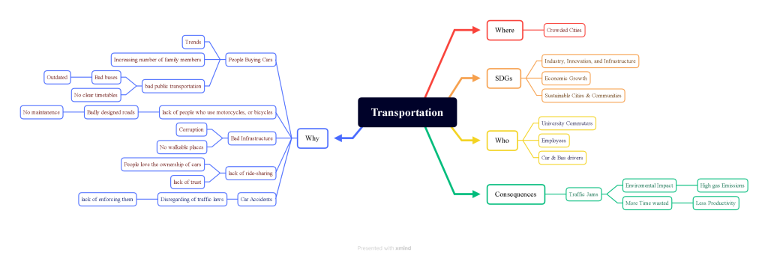

# Challenge Discovery

*Instructions: Answer the following questions. Remember that you will iterating and refining this as you move forward and carry on more research and development work.*   
  
**What mission or SDG have you chosen?**

* **INDUSTRY, INNOVATION AND INFRASTRUCTURE**
* **DECENT WORK AND ECONOMIC GROWTH**

1. **Why is this mission or SDG important? (300 words)**

Jordan in particular is one of the most known countries when it comes to a bad infrastructure, which is why we chose this mission, in the hopes of benefitting our country.

Using the Sustainable Development Goals (SDGs) adopted by the United Nations in 2015 as a global call to action to eradicate poverty, protect the planet and ensure that all people enjoy peace and prosperity by 2030, which follows 17 basic life goals such as ending poverty, good ةeducation, etc. We must all strive with them to achieve an ideal life of stability, sustainability and comfort for all. The 2 main reasons we chose these SDGs is because we want to benefit our region in fields where support is lacking, and we aim to create jobs for hundreds of people. While the main mission we want to work with is an infrastructure related one, we also want to give enough attention to economic growth and being sustainable, as Jordan is lacking in these 2 departments as well.

Jordan is one of the countries that are very interested in sustainable development goals, because companies are oriented towards combating the environmental and economic challenges they face, and calls on companies to apply creativity and innovation to solve these challenges. Which is why I think we will face minimal challenges. The Sustainable Development Goals help open up new business opportunities, and it is a good thing that everyone is able to contribute, whether male or female, young or old, we wish to impact a lot of people going forward with this project

 

1. **List the three most promising challenges you have identified from your research and challenge discovery mindmap(s)**.

|  |  |  |  |  |  |
| --- | --- | --- | --- | --- | --- |
| **Challenge or Problem** | **Affected Audience** | **What numbers or statistics can back up how big a problem it is? (Your business case)** | **Source of research** | **How big is this problem?**  **VL/L/M/S/VS** | **If solved, what is the benefit to the affected audience?**  **High/Medium/Low** |
| Ex: People with diabetes struggle to remember taking their insulin (on time & right dose) while maintain a healthy diet that is not hard to follow. | People with diabetes in the MENA region. | It costs the average family 400JD for a month's supply of diabetes whereas the average monthly salary is 300JD. With 20,000 families affected by diabetes, that's a 96 million JD per year market that many patients can't afford. | [www.diabetesresearch.com/average-family-cost.pdf](http://www.diabetesresearch.com/average-family-cost.pdf) | Very large  Large  Medium  Small  Very small | Medium |
| Car Accidents | Car drivers in Amman | Jordan witnessed 12,297 traffic accidents resulting in 12,690 injuries, 461 fatalities and JD296 million in financial costs in 2020. Over 58 per cent of the overall traffic accidents are car crashes, totaling 4,905 accidents. Most traffic accidents occurred in Amman, during July, and were majorly recorded on Thursdays, according to statistics. | <https://jordantimes.com/news/local/461-lives-perished-jordan-roads-2020-%E2%80%94-jordan-traffic-institute> | Medium | Large |
| Traffic jams | People living in centralized cities | For example, in the US, researchers determined the average American commuter wastes **54 extra hours a year** in traffic delays. In Jordan, traffic congestion losses amount to around 1.5 billion JDs | <https://www.jordannews.jo/Section-106/Features/Traffic-congestion-losses-amount-to-JD1-5-billion-annually-963>    <https://edition.cnn.com/2019/08/22/us/traffic-commute-gridlock-transportation-study-trnd/index.html> | Large | Medium |
| Low quantity of clean water | People living in countries with low sources of water e.g. **Jordan** | The drawdown from static water level between 1-20 m yearly. 40% of Jordan water resources is shared water.  Each Syrian refugee costs the water sector around 440 JD/year | <https://earth.org/countries-with-water-scarcity/> | large | Large |

# Final Challenge Statement

* *Instructions:*

*This will be your official Team Challenge Statement.*

*Complete this section only after you have done enough research, developed explorative mindmaps, engaged in  discussion, brainstorming and iteration.*

**How might we provide a better alternative to public transportation at an affordable price -- so that students and young professionals can reduce the time and effort wasted commuting.**

**Update:-**

**How might we improve the carpooling process – so that carpoolers feel that ride-sharing is more safe, reliable, and economical.**

# Research Questions

1. ***State your design research question below (this can and should change as you research more):***

***Note: In the initial phase of challenge discovery you may have more than one design research question, include them below.***

*How might we.. Reduce traffic jams so that the time wasted in traffic, is consumed productively*

1. ***PMR &SMR Research. Fill in the table below:***

*Instructions: This table will form the foundation of your research strategy. An answer to one question, should result in another question or more (see example below). Remember, you want to be experts in the challenge. Feel free to make this table as long as needed or create different tables if you explored more than one challenge. Ensure that you highlighted your research sources as either PMR or SMR.*

|  |  |  |  |  |
| --- | --- | --- | --- | --- |
| Major assumptions or questions to validate  We assume that... | Validation technique (Observe, Converse, Experiment)  We will validate this by... | Key insight or fact obtained from research:  We learnt/ observed that... | What does this insight or fact mean for your project?  We now know that... | Source (add links to sources or state who you spoke to): |
| People (more specifically students, and fresh graduates with jobs) have issues with the way they commute to their jobs/colleges. | By sending out surveys, we wish to gauge out how many people are affected negatively by transportation. | 66% of people said that the method of transportation they are currently using is affecting their life negatively. | Many people are suffering from transportation, many of those people are willing to change things up or try new things | PMR |
| A fair share of males and females use public transportation | Using surveys, and conducting face to face interviews | Public transportation is used a lot by both genders | Not only males are facing this issue, but females as well, and a large number of both | PMR |
| Cars or bus drivers would not hold on to their cars or, and not buy any new cars, if the transportation system was complete in all aspects. | By sending out surveys targeting drivers, we wanted to get as many people's opinions on this matter | 62% of drivers said that it could be possible, relying on how attractive that solution could be. | It is still unclear whether people would consider leaving their cars, or selling them in order to use a better transportation system. | PMR |
| Public transportation is not always available, which ultimately leads to more cars on the roads, thus more traffic | By sending out surveys targeting people who use public transportation, we wanted to get as many people's opinions on this matter | 65% of people said that public transportation is not always available, which is why it's one of the main factors why public transportation deters new users. | There is a huge problem with public transportation regarding clarity of timetables and routes. | PMR |
| People waste at least 1 hour commuting to their jobs/colleges | By sending out surveys targeting people who commute, we wanted to get as many commuters' opinions on this matter | 41% of commuters said it takes more than 1 hour of their daily lives, 27% percent said they waste around an hour | People waste a lot of time commuting, and they would be willing to explore other options that reduce this time. | PMR |
| The number of buses is insufficient | By researching online through various resources, we managed to dig up information regarding the number of buses | The global ratios are approximately one bus per 1,000 inhabitants, while in Jordan it is a bus per 3,000 persons | Buses are not a scalable tool of transportation, and it certainly isn't a reliable tool. | <https://alghad.com/%D9%86%D8%B3%D8%A8%D8%A9-%D8%A7%D9%86%D8%AA%D8%B4%D8%A7%D8%B1-%D9%88%D8%B3%D8%A7%D8%A6%D9%84-%D8%A7%D9%84%D9%86%D9%82%D9%84-%D8%A7%D9%84%D8%B9%D8%A7%D9%85-%D8%B6%D8%A6%D9%8A%D9%84%D8%A9-%D9%85%D9%82/> |
| People who carpool with people their ages have more fun, than carpooling with people who are not the same age | Live interviews, asking people straight questions regarding this matter | People do in fact enjoy carpooling when it's with people their age due to high probability of similar interests | People would be interested in applications where other riders have similar interests | PMR |
| Carpooling is only going to get bigger and bigger as a method of transportation | Researching online | At the moment there is an estimated number of 20 million cars in global carpooling projects. It is projected that just under 45 million vehicles will be in global carpooling programs by 2025 | Carpooling is a ripe market, and there is potential for market entry. | <https://www.statista.com/statistics/867668/carpooling-vehicles-worldwide/>  SMR |
| A high percentage of carpoolers have a negative experience when it comes to carpooling | Interviews | Around 66% of the people we asked stated that they faced negative experiences, in many areas of carpooling | There are issues with carpooling as a process, and solving them would attract customers | PMR |
| Carpoolers don't use carpooling as a main method of transportation due to lack of commitment from drivers | interviews | Most of the carpoolers we interviewed said that the driver can and most likely will leave them without notice if he found someone to pay more, and that it has happened to them before | Solving commitment issues will make carpoolers stick to this method more | PMR |

# Customer

*Instructions: In this section, you will be developing a customer persona. This is crucial to better understand who to target in your research and how to build an appropriate solution.*

1. **Customer Segments**

List all your users (those who will use your product) and customers (those who will pay for it) below. For example, if you are selling educational tech for children, they are your users but their parents, schools or government might be your paying customer.

* *University students (users & customers)*
* *Fresh graduates (users & customers)*

1. **Customer Personas**

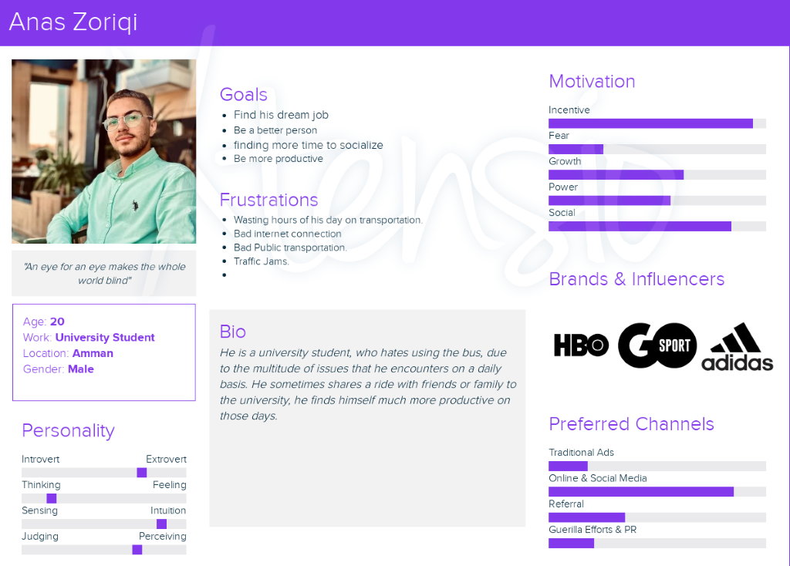

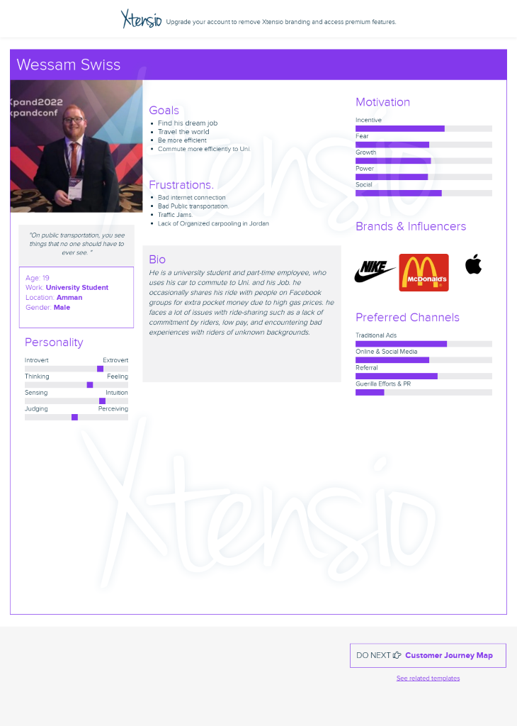

**Examples**

**Tips**

1. **Facts**

Describe your customer in more detail, including but not limited to: 

* Short Description.
* Age range.
* Males/Females/Both.
* Job.
* Location/Geographies.
* Any other relevant information.

1. **Bio/Behaviours**

Describe what customers are trying to get done in their work and in their lives as it relates to your challenge statement, and as expressed from their perspective and in their own words. 

Think about what they want to achieve in terms of: 

* Functional
* Emotional
* Social

1. **Goals (or gains)**

Describe the outcomes customers want to achieve or the concrete benefits they are seeking.

*What would make your customers’ jobs or lives easier? Could there be a flatter learning curve, more services, or lower costs of ownership? What positive social consequences do your customers desire? What makes them look good? What increases their power or their status?*

1. **Frustrations (or pains)**

Describe bad outcomes, risks, and obstacles related to customer jobs.

*What makes your customers feel bad? What are their frustrations, annoyances, or things that give them a headache? What negative social consequences do your customers encounter or fear? Are they afraid of a loss of face, power, trust, or status?*

# Idea Brainstorming

*Instructions: Use this section to showcase drawings and sketches of your solution ideas. There are****FOUR steps on this page****(scroll down)*

**Paste all of your ideation sketches and notes below** 

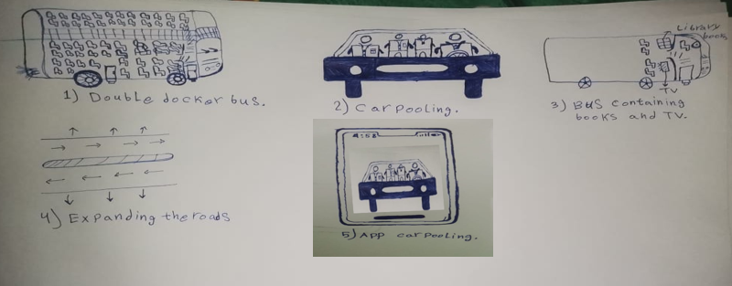

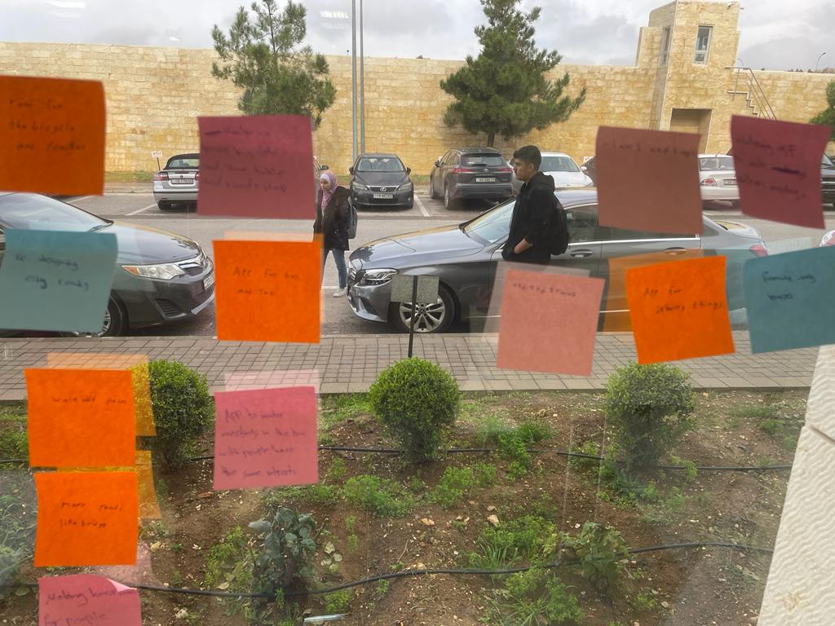

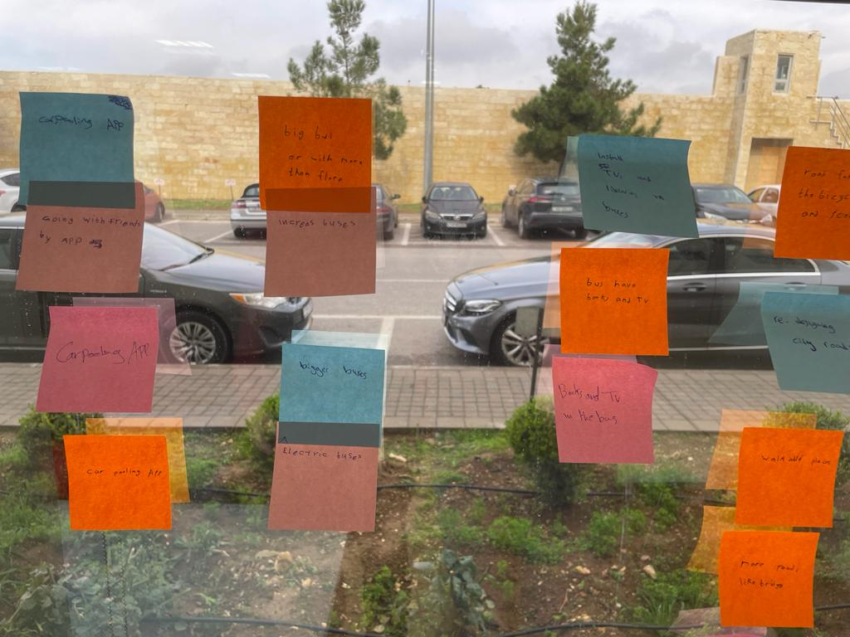

**2- List between 5 and 10 of your favorite ideas:**

* **Expanding the roads and developing the infrastructure.**
* **Awareness campaigns for walking and bicycles.**
* **Increase the usage of the electrical cars to reduce the gas.**
* **Making an application to monitor and organize the public bus transportation process.**
* **Increasing the number of buses and converting it into electric buses.**
* **Establishing projects for express trains for long distances.**
* **Making carpooling project between the crowded cities.**
* **Exploiting passengers' time in something useful.**
* **Make buses corporate owned, not individually owned.**
* **Using Drones for delivery to reduce the number of delivery cars.**   
     
     
     
  1. **OPTIONAL: Map them on the 'Effort vs Impact' graph below:**

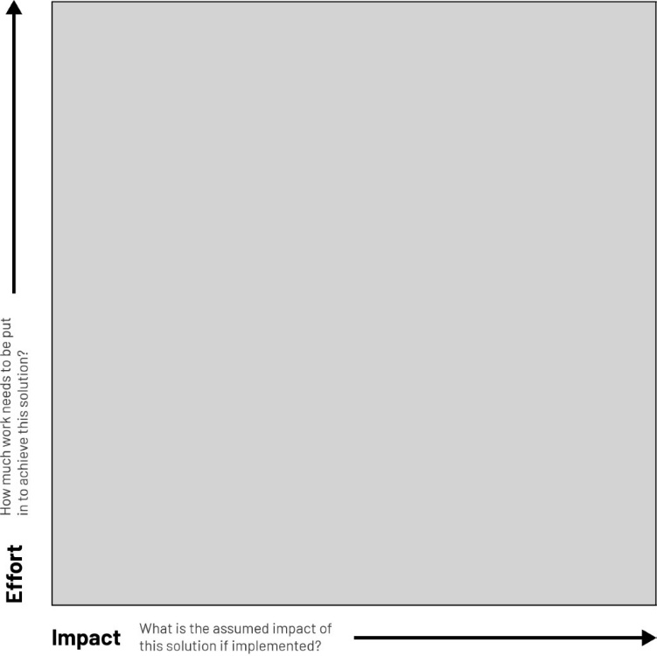

1. **Narrow down to *THREE ideas that you are most convinced, as a team, will have the most impact.***

* **Making carpooling project between the crowded cities.**
* **Increase amenities (TVs, Books) in buses.**
* **Making an application to monitor and organize the public bus transportation process**

# Prototyping Plan

*Instructions: Use this section to document your prototyping and idea validation journey*

|  |  |  |  |
| --- | --- | --- | --- |
| **Prototype**  *What is your prototype?* | **Validation**  *What are you hoping to learn?*  *Idea validation, functionality of a prototype, desirability of a prototype?* | **Observation**  *What did you learn from building and testing your prototype?* | **Next steps**  *Based on what you learnt, how will you better the next prototype?* |
| Application Prototype Version 1 (**Tareeq**) | Idea Validation (from the passenger's and driver's side)  Navigation  User-friendliness  Requirement testing | From Building:   1. Doing both sections of the app (driver & rider) using the same interface, proved to be difficult to organize. 2. We learned more from building, than actually thinking about building. 3. We need to add a different service (VIP Service) for a different revenue stream, and to attract more customers.     From Testing:   1. Our UI & UX needed some more work. 2. Users found it difficult to navigate to and from certain points in the application. 3. It took more time to test the prototype than planned, which means either our prototype needs more time to test, or it was too complicated for the users which means making it simpler would fit within the time frame foretold. 4. Some users understood the concept of the app fairly quickly, while others didn't. 5. Some users showed interest regarding the concept of riding with people with similar interests, and expressed that they like this idea and would want us to work more on it | We're considering removing the list (top corner) and rely only on one type of navigation which is the bottom navigation bar, because while observing the users we found many of them mainly using the bottom navigation bar, and when they realized what they're looking for isn't in there, they used the list (top corner).    We will also be adding more options in the "preferences" page so that it will allow longer trips to be fathomable.      Rewards for referrals |
| Application prototype Version 2 (**Tareeq**) | Idea Validation (from the passenger's and driver's side)  Navigation  User-friendliness  Requirement testing | We noticed that users still took more time to navigate and get the hang of the application, because some of them had never carpooled before and didn't understand what it is from our existing explanation In the about us page | We will be adding a detailed page containing a tutorial on how to use the app, so that people who have never carpooled can understand more about it. |
| Application prototype Version 3 (**Tareeq**) | Idea Validation (from the passenger's and driver's side)  Navigation  User-friendliness  Requirement testing | No negative feedback. The testing was finished within the time allocated for it | No next steps |

# Solution Description

*Instructions:* *This section will help you make sense of your solution.*

**1. Elevator Pitch. Describe your solution in no more than four lines.**

The solution is an application that delivers passengers to the places they want, and the drivers are employees or students, and sometimes they are passengers, so that the customer can switch his account at the time he wants, whether a passenger or a driver as needed. It also offers the advantage of knowing the driver and passenger's personalities, so that a social relationship is established between them.

1. **What is your condensed value proposition statement.**

*For – target customer*

*Who has – goals*

*Our product or service is a –  category*

*That unlike – specific alternative(s)*

*Provides – compelling rationales*

***Example***

For -  *middle to high-income families in Jordan.*

Who – *want healthy options & convenience.*

Bazela.com – *is a virtual marketplace for fresh produce.*

That unlike – *supermarkets, street vendors, and other grocery apps.*

Provides – *smart & convenient way to source certified-organic produce; local producers; competitive pricing; promotes agricultural sector and creates jobs.*

Who – *want healthy options & convenience.*

Bazela.com – *is a virtual marketplace for fresh produce.*

That unlike – *supermarkets, street vendors, and other grocery apps.*

Provides – *smart & convenient way to source certified-organic produce; local producers; competitive pricing; promotes agricultural sector and creates jobs.*

For -  *low to middle-income employees/students  in Jordan.*

Who – *face issues in public transportation and the carpooling process.*

Tareeq-  *is a carpooling application that relies on commuting employees/students to give rides to commuting employees/students while going to work/university..*

That unlike –*SWVL, and other carpooling apps, doesn’t rely on full/part-time drivers, and doesn’t rely on station-to-station rides*

Provides – *organization of carpooling rides between drivers and riders, on a geographic and demographic basis*

# User Testing

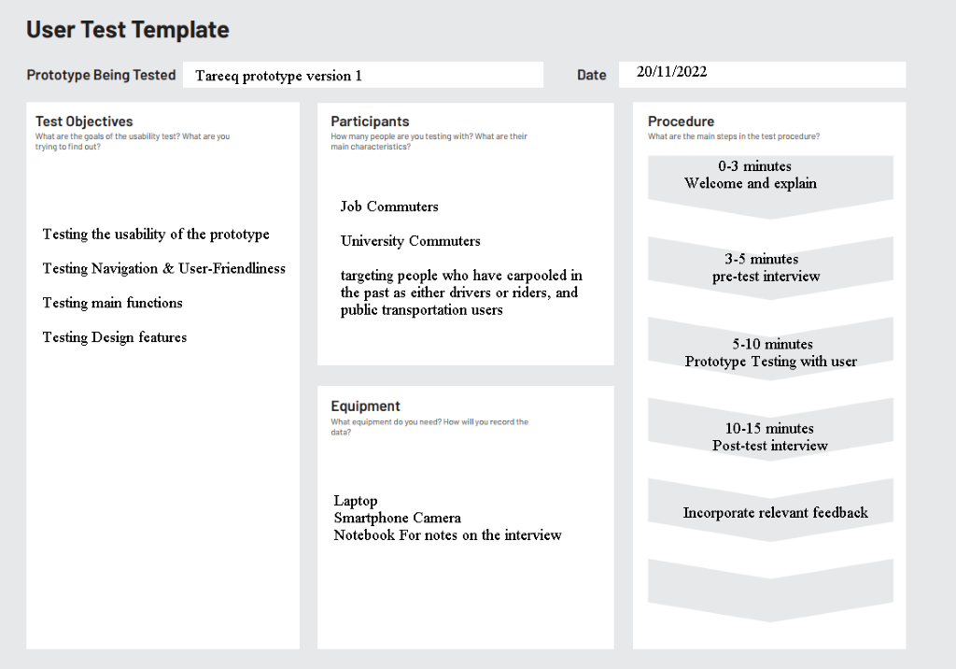

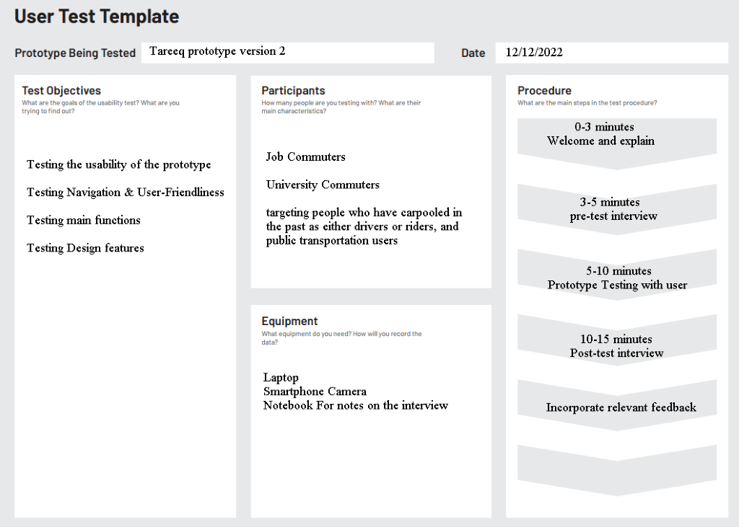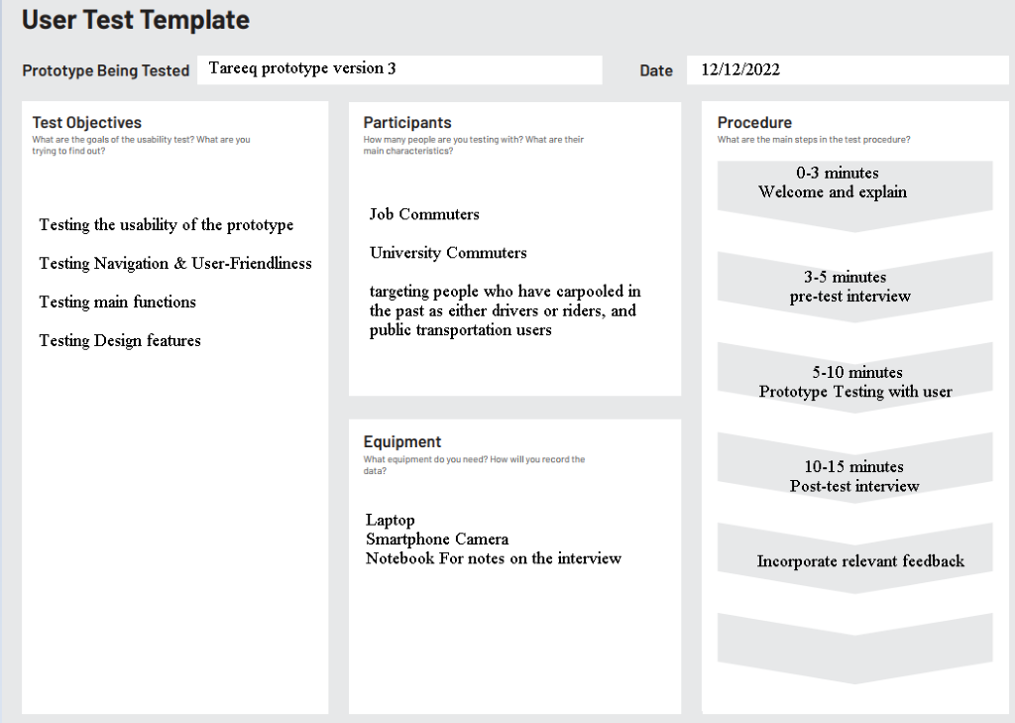

# Features & Benefits

*Instructions: In this section, you will describe the products and features of your product or service.*

1. **Features**

Features are elements of your product or service that make it special.

* Ease of use
* Lower Price
* Ease of switching the account between the passenger and the driver without the need to create a new account or download another application
* There will be rider and driver preferences to improve the rating
* The customer obtains discounts due to frequent use of the application.
* Good UI & UX
* Provide detailed reports on the history of the request
* Access real-time information about their requests

1. **Benefits**

Benefits are the positive impact your product provides to the customer

* Reduce congestion in the streets.
* Save Time & Money.
* Spend less time while commuting
* Reduces carbon emissions
* To enhance efficiency by shortening transportation times and improving transportation methods
* Trusting the carpooling process

# Value Proposition Canvas

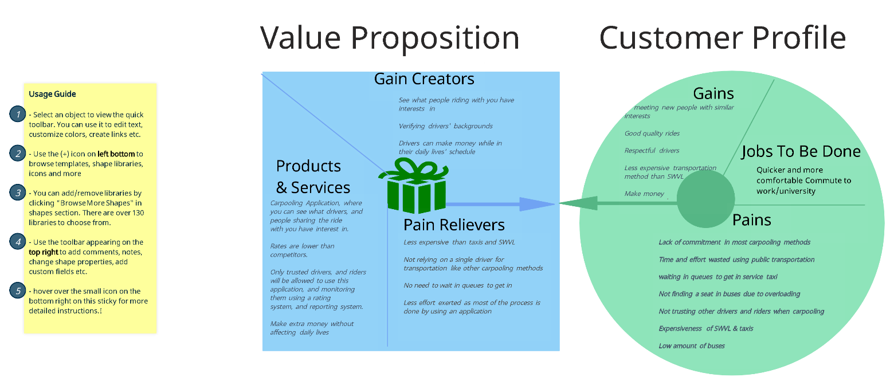

*Note: When you talk with your customers, don’t show them the canvas – it’s better to ask natural questions that help you fill in each box, rather than using all of the same terminology.*

|  |  |
| --- | --- |
| **Value Map** |  |
| **Customer Jobs** | **This is a list of all the Products and Services you offer for the targeted segment.**     * … * … * … |
| **Gains** | **Describe how your products and services create customer gains & delight.**     * *Describe the most important features. What is special about it?* * *Describe the most important benefits. What does it do for the customer?* |
| **Pains** | **Describe how your products and services alleviate customer pains.**     * *Bad Public transportation* * *Expensiveness of taxis in relation to their salary* |

|  |  |
| --- | --- |
| **Value Map** |  |
| **Products & Services** | **This is a list of all the Products and Services you offer for the targeted segment.**     * … * … * … |
| **Gain Creators** | **Describe how your products and services create customer gains & delight.**     * *Describe the most important features. What is special about it?* * *Describe the most important benefits. What does it do for the customer?* |
| **Pain Relievers** | **Describe how your products and services alleviate customer pains.**     * *Fix underperforming solutions? By introducing new features, better performance, or enhanced quality.* * *Put an end to difficulties and challenges your customers encounter. By making things easier or eliminating obstacles.* |

# Market Size

*Instructions: For investors to fund an early stage startup, they need to know how many customers you can potentially reach and sell to so they can better understand the potential returns on their investment. Use this section*

1. **Is your business a B2B, B2C or B2G, explain?**

B2C. Our application is meant to be used by customers, who are ultimately looking for a ride, or looking to pick up people for a sum of money. it is not meant to be used exclusively by companies or governments.

**2.    What is your TAM/SAM/SOM?**

*This section of your plan should explain:*

* *The total size of your industry*

The **Global Carpooling Market**is expected to grow from **USD 16.1 billion** in 2020 to **USD 53.1 billion** by 2026 at a **CAGR of over 22.3%** during the forecast period.

* *Describe any important trends in the industry?*

*Gas emissions --> due to climate change getting worse and worse by the year, more and more environmental movements are starting to get to people, many of which are getting people into ride-sharing to reduce gas emissions*

* *Is the industry growing or shrinking? At what rate?*

*Growing*

Revenue is expected to show an annual growth rate (CAGR 2022-2027) of 7.32%, resulting in a projected market volume of US$16.91bn by 2027. (Globally)

* *The total size of your target market, and what share is realistic for you to obtain? TAM/SAM/SOM table.*
* *How are customer needs or preferences changing?*

*Note:*

*Market size is usually a revenue number such as $1 billion but can also be represented as unit volume such as 1,650,000 units.*

|  |  |
| --- | --- |
| **TAM**    Total Addressable Market | **What is the total market demand for your product or service?**    Ex. Carpooling app targets all carpoolers in the world    *How did you determine your TAM? List important assumptions made.*     * *Revenue in the Car-sharing segment is projected to reach US$11.88bn in 2022.* * *In the Car-sharing segment, the number of users is expected to amount to 62.1m users by 2027.*     How did you determine your TAM? List important assumptions made.   * We used the statistics on a website called Statista. * Number of projected car-sharing users |
| **SAM**    Total Attainable Market | **What is the segment of the TAM targeted by your products and services which is within your reach?**    Ex. Our carpooling app targets all carpoolers in Jordan    *How did you determine your SAM? List important assumptions made.*       * Revenue in the Ride-hailing & Taxi segment in Jordan is projected to reach 214m JDS in 2022. * The average revenue per user (ARPU) is expected to amount to US$116.30.     How did you determine your TAM? List important assumptions made.   * We used the statistics on a website called Statista. |
| **SOM**    Total Obtainable Market | **What is the portion of SAM that you can reasonably capture within the first 3 years?**    *Our carpooling app targets 30% of carpoolers in Jordan (65m JDs) by 7-9 years*    *How did you determine your SAM? List important assumptions made.*   * *Logical percentage*     How did you determine your TAM? List important assumptions made.   * We used the statistics on a website called Statista. * Number of people in carpooling groups. * The amount of people that we can realistically reach through ads |

**3. What are the sources you used for each number you find?**

* <https://www.statista.com/outlook/mmo/shared-mobility/shared-rides/car-sharing/worldwide>
* <https://www.statista.com/outlook/mmo/shared-mobility/shared-rides/ride-hailing-taxi/jordan>

# Competitive Landscape

*Instructions:* In this section, you will highlight what makes your product innovative and unique in comparison to your competitors.

1. **Direct Competitors**

List all of your direct competitors below. These are companies that provide a similar product or service to you and what do they offer. *Write a sentence about their offerings.*

* **SWVL:**provides delivery services, especially carpooling, and they are the most well-known in the carpooling market. Although their services are currently suspended, many customers complain about the high prices and lack of availability of the service. It is also not easy to use on the driver and passenger side. Also, lack of communication from SWVL is a big problem as many people don't know whether they are operating or not.

* **Facebook & WhatsApp Groups:**unregulated carpooling occurs on many groups dedicated for carpooling, each for group is dedicated to people living in a certain city. Number of people in these groups are proportionally extremely low when compared with the population of the city. Prices are not consistent and vary from driver to driver, usually there is no trust when dealing with new drivers or riders, as they have unknown backgrounds.

1. **Indirect Competitors**

What other products or solutions are people using that might work for them but are very different to what you or your direct competitors offer? *Write a sentence about their offerings.*

* Uber provides delivery services, and it is the largest in the market, and although the prices of their services are above average, they do not target all groups, as their services are relatively expensive for long-distance transportation, and on the driver’s side, they require some complications.
* ...

1. **Use the below table to better understand your competition:**

|  |  |  |  |  |
| --- | --- | --- | --- | --- |
|  | **Your startup** | **Competitor 1** | **Competitor 2** | **Competitor 3** |
| **Company overview** | Tareeq: delivery service and an opportunity earn money | Facebook & WhatsApp groups | SWVL: delivery services | Uber: delivery services |
| **Type of competition** |  | Direct competitors | Direct Competitors | Indirect Competitors |
| **Value proposition** | Delivery service at excellent prices for a group of people, and an opportunity to make money, with regulated pricing, rating and reporting system, and the ability to ride with people with similar interests | Delivery service at varying prices for a group of people, and an opportunity to make money | Delivery service at good prices for a group of people | Delivery service is like a taxi, but with high quality and a competitive price |
| **Target market** | People from the low class to the middle class, from 18 to 35 years old, male and female. | People from the low class to the middle class, from 18 to 60 years old, male and female. | People from the low class to the middle class, from 25 to 34 years old, male and female. | People from the middle class to the high class, from 16 to 65 years old, male and female. |
| **Products & services** | Carpooling application, with lower rates than competitors, with only trusted drivers and rider allowed on the app, by utilizing rating and reporting system, make extra money without affecting daily lives | Carpooling group, unregulated carpooling. Certain arrangements happen between drivers and riders based on posts they've made regarding the exact whereabout of the starting point, destination, and the way between. | Group delivery services and providing semi-formal work | Individual delivery services and goods delivery   ,providing semi-formal work |
| **Costing & prices** | For each person  start 0.5  (0.05 JOD per kilometer )  0.01 per minute | Varies from driver to driver | * Base Fare + ((Cost per minute x time of the ride) + (cost per mile x ride distance) x surge boost multiplier) + booking fee = Passengers Ride Fare |  |
| **Marketing strategy** | We will reach our customers through:  *Social media marketing = daily*  *Mobile marketing*  *Search engine optimization*  *Networking*  *Word-of-mouth*  *Referrals* | Social media marketing  Referrals  Word of mouth |  | 1. Early Adopter Advocacy  2. Referrals  3. Reviews  4. Stunts  5. Partnerships  6. A Loyalty Program  7. An Omni-Channel Approach |

**& more ..**   
 

1. **Unique Competitive Advantage (up to 150 words)**

Describe in as much detail as possible what makes your product or offering unique. What do you do that your competitors do not? (Hint: Lower prices is not a good enough reason!)

Our application services are distinguished in several respects, the simplest of which is the appropriate price for all categories, and the most important of which is that the application is used by two types of users, the driver and the passenger, and each party can be the other so that the driver does not remain a driver and he is not forced to work and can be a passenger. The service of knowing the interests of the driver and the passenger for each other, so that we provide a comfortable and pleasant trip for both parties

# Marketing Mix

*Instructions:* *This section will help you better understand your offering and how you will market it to your customers. Fill in the final column only – we have given you prompts in the middle column to help you out.*

|  |  |  |
| --- | --- | --- |
| **Product** | **What is the product or services your business provides to your target audience?**    A carpooling application that any individual over 18 years of age can partake in. | **Our product is....** |
| **Place** | **Where and how will people buy your product?**    *Online application, they can find it on app store, and google play* | **Location:**    **How people will buy:** free |
| **Price** | **How you will price your product or service**:    15% rate on all rides | **Price of product or service:**  Free, only requires internet to download, the rate of the service is 15% per ride    **It's priced like this because: it’s the best percentage so that our application, and drivers on this application can generate profit, while maintaining the good pricing for riders** |
| **Promotion** | **List the tools & channels of advertising that reaches a company's target market.**    *Advertising may include:*   * *Online marketing* * *Radio* * *Cable television* * *Out-of-home* | **We will reach our customers through:**     * *Social media marketing = daily* * *Mobile marketing* * *Search engine optimization* * *Networking* * *Word-of-mouth* * *Referrals* |

# Brand Voice

*Instructions: In this section, you will showcase your branding. How do you want your customers and competitors to view you?*

1. **What three words do you want customers to associate with your brand?**
   * Comfortable, No hassle, Trusted
2. **Why have you chosen these words in particular?**

Comfortable: because the rides you will get are 100% more comfortable than public transportation.

No hassle: Avoiding the hassle of looking up posts on Facebook, to see if any ride fits your description, or posting yourself looking for people to pick up on your way to work, or university

Trusted: The rider can trust the driver more due to services provided by the application, such as tracking, rating, and reporting system, and vice versa, due to the driver also having more information about the rider

1. **Do you have a slogan?**

One request, we do the rest.

1. **Design elements:**   
   1. **Include your logo and any other branding visuals here:**

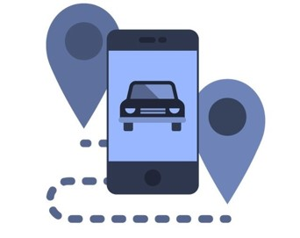

* 1. **Why have you chosen these colors for your brand?**

Carrying the blue symbolism associated with the darker shades of blue, navy conveys importance, confidence, power, and authority, as well as intelligence, stability, unity, and conservatism. 

We picked this name, because it describes the nature of the work of the application "Tariq" and describes the relationship between the customer and the service that is provided and improving the customer's impression.

The logo gives a clear indicator that the application is related to transportation, and if you have carpooled before, you will most likely understand from the logo that is about ride-sharing 

# Go To Market

*Instructions:* *The Go to Market campaign is how you intend on raising awareness about your product and attract new users to use it. You might think social media is the most effective solution, but think of how you will inspire word of mouth and referrals. For example, if you are launching a new type of food, you might want to set up a booth to offer tasters for free.*

1. **List all the potential marketing channels you can think of.**

Make a list of different things you can do to raise awareness. Social media campaigns, door-to-door brochure distribution, send your product to relevant magazines etc.

* Social media campaigns
* Street billboards
* Search engine marketing
* Display advertising
* Digital PR
* Digital partnerships
* Digital messaging
* Websites/Blogs
* Email Marketing
* Video Marketing
* Influencer Marketing
* Radio marketing
* Print marketing materials (brochures, flyers, business cards)
* E-commerce website.
* A booth in a mall to introduce the application and distribute discounts

1. **What metrics would you measure to gauge if your marketing plan was a success?**

*E.g bazela.com signed 10 contracts with organic farmers with 500Kg/week production capacity (to ensure variety & availability).*

* Reaching 20000 trip in the first year.
* Signing a contract with governmental and private universities to promote and increase passengers
* Sign contracts with gas station to enable offline payments through card exchange
* Sign contracts with sponsors to get more publicity

# Initial Operating Expenses

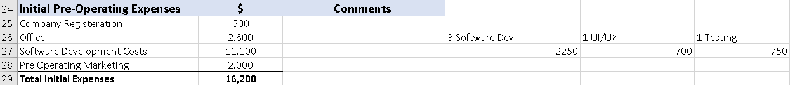

# Cost Structure

Instructions:

**List all fixed cost & variable cost for your products & services.**

*Costing refer to all the costs incurred by a business from manufacturing a product or providing a service. Production costs can include a variety of expenses, such as labor, raw materials, consumable manufacturing supplies, and general overhead.*

***A Fixed Cost refers to costs that your startup incurs on a regular basis, they are generally predictable and incurred at fixed intervals such as monthly or yearly. Your startup will incur these costs regardless of the volume of products or services produced and sold.***

***Some examples of fixed costs include:***

* *Rent*
* *Telephone and internet costs*
* *Insurance*
* *Employee Salaries*
* *Loan Payments*

***A variable cost is an expense that changes in proportion to production output. Variable costs increase or decrease depending on a company's production volume; they rise as production increases and fall as production decreases.***

***Some examples of variable costs include:***

* *Direct labor (different than salaried employees)*
* *Production Supplies.*
* *Direct Materials.*
* *Commissions*
* *Taxes*
* *Operational expenses*

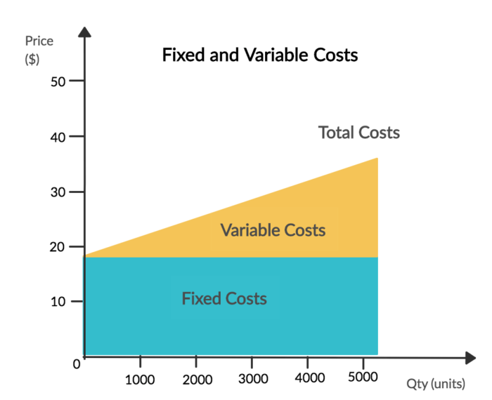

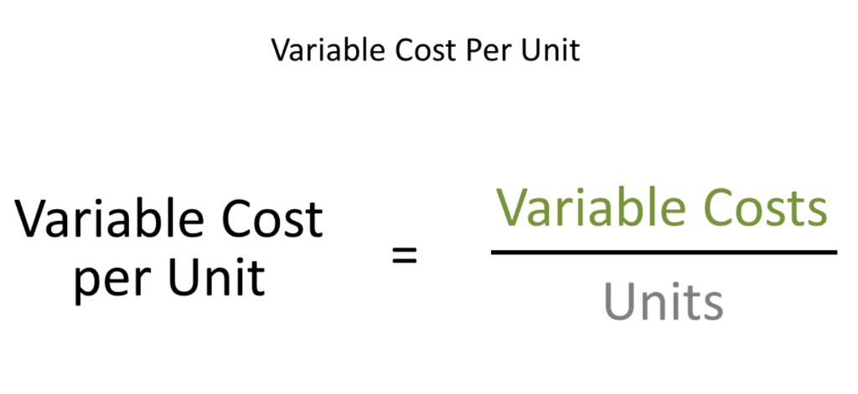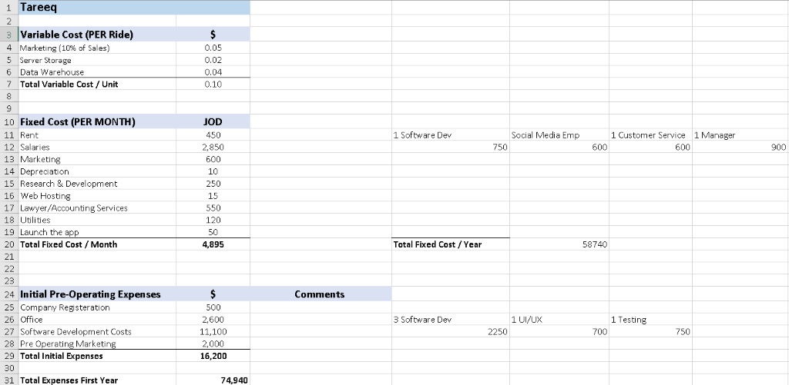

# Revenue Model

**Instructions:***The Revenue Streams represents the cash a company generates from each customer segment (costs must be subtracted from revenues to create earnings)*

*Consider these questions as you are developing your revenue model:*

*For what are customers paying now to solve their problem? How are they currently paying? How would they prefer to pay?*

*Note:*

*A business model can involve two different types of Revenue Streams:*

*1. Transaction revenues resulting from one-time customer payments*

*2. Recurring revenues resulting from ongoing payments to either deliver parts of the Value Proposition to customers or provide post-purchase customer support.*

**List all products & services your company provide as main revenue streams.**

Describe all of your products or services, being sure to focus on the customer’s point of view.

|  |  |  |
| --- | --- | --- |
| **Customer Segments** | **Product/service** | **Revenue Stream(s)** |
| 1. Rider segments | Basic Rides (Meet the driver at a specified destination on the way) | *One time transaction.* |
| 1. Rider segments | VIP Rides (The driver comes to pick you up for extra money) (the driver can refuse) | *One time transaction.* |

# Pricing

**How you will price your product or service**?

*Describe the pricing, fee, subscription or leasing structure of your product or service. How does your product or service fit into the competitive landscape in terms of pricing—are you on the low end, mid-range or high end? How will that pricing strategy help you attract customers? What is your projected profit margin?*

**Types of Pricing Strategies**

**Cost-plus pricing**—simply calculating your costs and adding a mark-up

**Competitive pricing**—setting a price based on what the competition charges

**Value-based pricing**—setting a price based on how much the customer believes what you’re selling is worth

**Premium pricing**—setting a price based on differentiated high quality offering.

**Price skimming**—setting a high price and lowering it as the market evolves

**Penetration pricing**—setting a low price to enter a competitive market and raising it later

**Bundle pricing**—setting a lower price for bundles items/services to encourage customers to buy more.

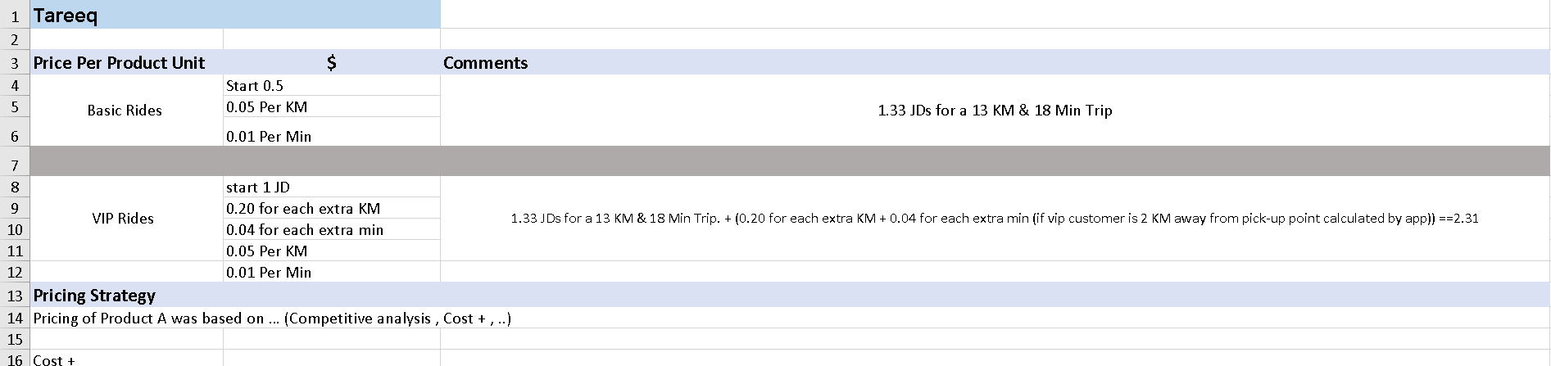

# Breakeven Analysis

**Instructions:** The calculation for the break-even point can be done one of two ways; one is to determine the amount of units that need to be sold, or the second is the amount of sales, in cash, that need to happen.

46,000,000 M Total Market in Jordan

30% of Total Market Share = 13,900,000 M (Our Share)

13,900,000 M JDs Market Share --> our commission 15% --> 2,000,000 over the next 9 years

220,571 JDs/Year

18,000 JDs/month

600 JDs/day

485,500 ride/year

39,500 ride/month

1,300 ride/day

0.45/ride

600 daily revenue * 10%(marketing) = 60   
60/1300 = 0.045 marketing on each ride

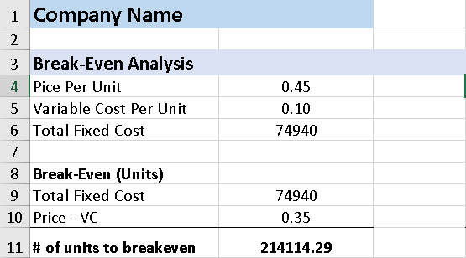

*Ex.*

Khaled is a juice manufacturer in Amman. He is considering introducing a new soft drink. He wants to know what kind of impact this new drink will have on the company’s finances. So, he decides to calculate the break-even point, so that he and his management team can determine whether this new product will be worth the investment.

His accounting costs are as follows, for the first month the product will be in production:

Fixed Costs = $2,000 (total, for the month)

Variable Costs = .40 (per can produced)

Sales Price = $1.50 (a can)

=Fixed Costs ÷ (Sales price per unit – Variable costs per unit)

=$2000/($1.50 – $.40)

=1818 units

This means Khaled needs to sell just over 1800 cans of the new soda in a month, to reach the break-even point.

# Projections

1st year projection

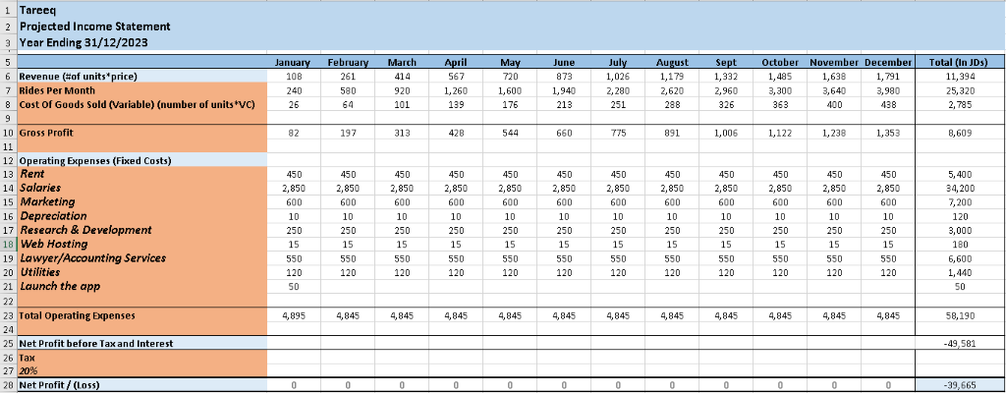

2nd year projection

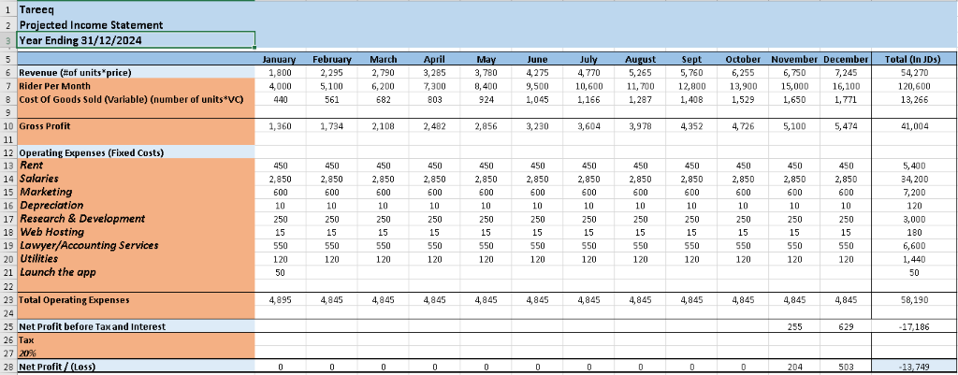

3rd year projection

